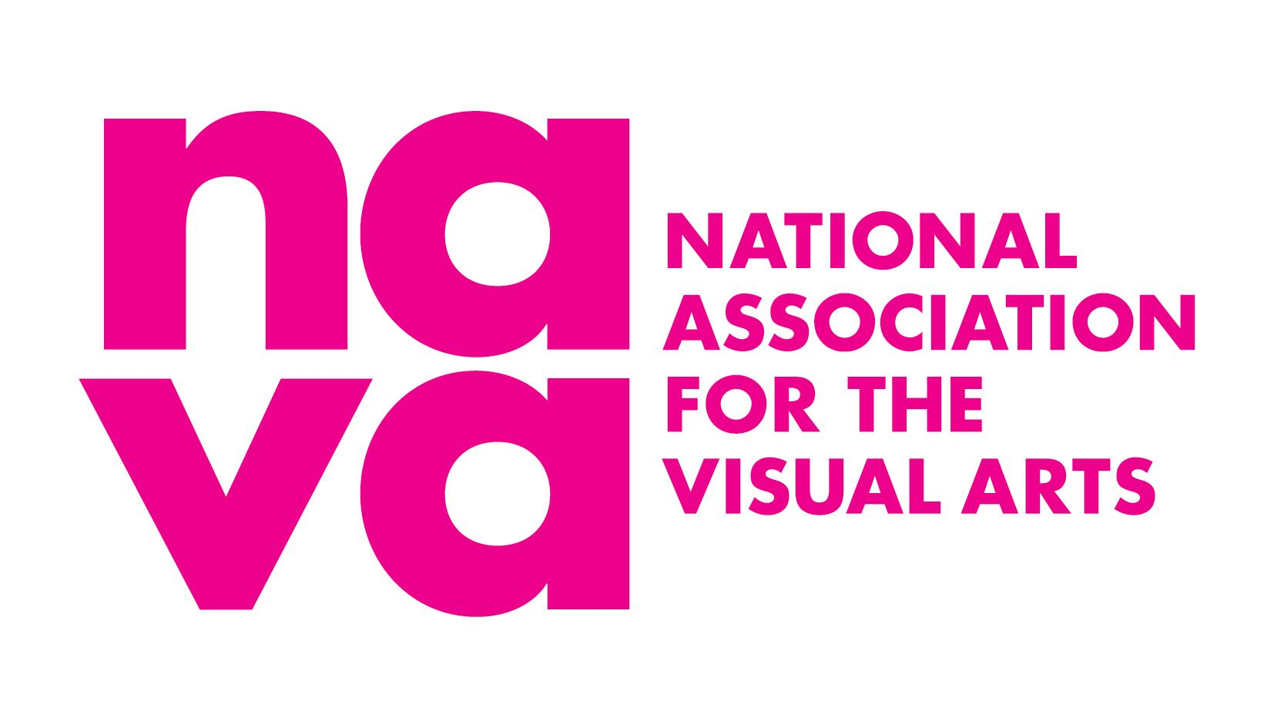

NAVA Premium Plus Membership Factsheet

The National Association for the Visual Arts (NAVA) offers an annual insurance membership package available to visual artists, craft practitioners, designers, conservators, installers, registrars, curators and arts administrators working across Australia. This package is available to sole practitioners, partnerships, trusts, groups and organisations/companies.

The policies arranged by Cover for Creatives Pty Ltd provide cost-effective insurance and broad policy coverage for these types of insurances:

- Public and Products Liability (includes third party Property Damage): $20,000,000
- Professional Indemnity: $5,000,000
- Third party Property in physical or legal control: $250,000
- Personal Accident: 85% of Income up to $1,000 per week for 52 Weeks

Am I eligible?
Premium Plus Membership is offered to artists and arts workers considered to be professional according to the criteria listed in the Professional Assessment Criteria document.
You must have an active ABN and be operating as a Sole Trader, Partnership, Pty Ltd, or Company structure. The Partnership structure must be made up of two creatives who meet the Professional Assessment Criteria mentioned above.

Cover is available for Australian and New Zealand citizens, temporary visa holders, asylum seekers and refugees – provided that you conduct work in Australia, and hold an active ABN and all appropriate working visas.

Partnerships, Pty Ltd and other company structures
NAVA Premium Plus Membership can insure Partnerships, Pty Ltds and other Company structures, covering individuals working under the group’s ABN.

The group, collective or company can hold a single Premium Plus Membership to cover a group of up to five people. Each additional person (members 2 - 5) of the group will be listed on the application form and must join as an individual NAVA Premium Member for the full year before the Premium Plus Membership can be approved.

For groups with more than five people please contact NAVA to discuss further.

If you also have your own ABN as an individual artist, you need a separate Premium Plus Membership to cover work done under that individual ABN.

Types of insurance cover
Below are brief descriptions of the types of insurance and cover you will receive as a Premium Plus Member. For full details of the terms, conditions, and exclusions, refer to the policy wording provided.

- Combined Liability Insurance

What does the Combined Liability policy cover?
Liability insurance is often a condition of undertaking public projects, working in certain spaces or if people visit your own office, studio or workshop. It ensures you are covered if another person is injured or their property damaged as a result of your negligence.

Primarily this insurance package intends to cover you, the artist or arts worker, for all artistic related activities and extends to include:

- as an occupier of an office, studio or workshop (either at home or in rented premises);
- as a consultant or contractor at various locations including galleries/exhibitions, events, festivals, and market stalls.

This insurance policy only provides cover for your legal liability(ies). You should be regularly undertaking risk management strategies to mitigate potential hazards.

Following is a summary of the main aspects of this policy.

Public Liability
This policy protects you from the financial risks of claims made by other parties for compensation due to injury or property damage caused by your activities or products. It covers the costs of investigating, defending and/or settling these claims.

The policy will defend any allegations that you are legally liable for, and if you are found responsible, pay damages and legal expenses to the limit of the policy subject to the policy conditions.

Example scenarios:
- A visitor trips over an electrical cable at an artist’s open studio, sustains an injury, and files a claim for medical expenses.
- A public artwork collapses during installation, injuring a passerby who seeks compensation.
- A prop in a live performance accidentally strikes an audience member, leading to a claim for medical costs and damages.

Tenants Liability
This policy provides cover for property damage claims if you are working in a rented space or temporarily using premises for your business. It includes damage to premises you lease or rent, including fixtures and fittings, as required by your rental agreement.

Example scenario:
- An artist occupying a rented space spills chemicals on the carpet, requiring it to be replaced.

International cover
This policy covers you if you are travelling overseas to undertake a residency, exhibition, research or lecture at a conference. These policies have a limited period of 90 days or less for selected destinations. We advise that you confirm your overseas coverage with our broker before travel as restrictions may apply.

Assistants and Volunteers cover
Paid assistants and Volunteers are automatically covered by Liability insurance.

Products Liability
A ‘product’ is anything you make, manufacture, sell, or supply. This policy covers your legal liability to members of the public related to any artwork, product, sale or supply of your products, resulting in injury, sickness or death.

Example scenario:
- A ceramicist creates a series of drinking cups and one cup has a rough edge that they forgot to smooth. A member of the public cuts their lip while using the cup and seeks compensation.

This policy does not extend to cover product recalls.

Professional Indemnity
This policy protects you from the financial risks of claims made by other parties alleging they have suffered financial loss due to a breach of your professional duty, such as a mistake, incorrect advice, or other errors or omissions emanating from the services you provide.

Example scenarios:
- An artist is commissioned to create a mural for a high-profile public space. The client makes a claim alleging that the mural does not meet the agreed specifications (e.g. incorrect dimensions, colours, or design elements), causing the client reputational or financial damage.
- A curator loses critical documents, such as loan agreements or shipping paperwork, resulting in project delays and additional costs to recreate them.
- An arts educator inadvertently makes defamatory statements about another professional during a lecture, leading to a claim for reputational damage.
- An arts consultant advises a collector to invest in an emerging artist’s work. The client makes a claim alleging that the consultant gave negligent or misleading advice, as the artist’s market value declines and the client suffers financial losses.

Teaching
This policy intends to cover artists and arts workers who may be teaching or passing on skills through classes or similar teaching sessions. The artist or arts worker may facilitate these workshops in their own name, or they may be contracted at a school, university, state institution, not for profit or private organisation.

Third Party Property in Physical or Legal Control – Policy Limit: $250,000
This policy covers damage to other property under your care, custody or control. This includes personal belongings of visitors, such as bags or phones, while they are on the premises, as well as temporary use of buildings. Cover also extends to vehicles on your premises, provided they are not in a paid car park and the damage is unrelated to vehicle operation.

Example scenarios:
- A curator borrows a camera and accidentally drops it, causing damage.
- An artist borrows equipment that is then stolen from their studio because they left the door unlocked.
- You are held liable because a Visitors’ personal belongings (such as bags, phone, laptop) are stolen or damaged.

- Personal Accident Insurance

This policy, sometimes called Personal Injury Insurance, provides worldwide 24 hour 365 day protection, excluding time on any other employment other than the visual arts practice and excluding travel to and from such employment. It includes coverage for Loss of Income, offering a weekly injury benefit up to 85% of Income to a maximum of $1,000 per week - if you are unable to work for a period due to the injury. It also covers death and capital benefit maximum of $50,000. There are some medical costs coverage depending on the injury. Please refer to the policy on page 21 to 24 for a schedule of benefits.

Volunteers cover
Personal Accident cover can be extended for Volunteers you engage for an additional overall cost of $10 + charges ($11.69 including GST and Stamp Duty) – per Volunteer. If cover is required for Volunteers, simply contact Cover for Creatives to arrange. Paid assistants are automatically covered for Personal Accident.

Personal Accident insurance is not a replacement for health insurance, life insurance, travel insurance or Workers’ Compensation. This policy does not cover cases where the insured is unable to work due to sickness or illness.

Special Age Limit Provisions apply. See page 13 of the Personal Accident policy wording.

What this policy cannot cover
- This policy does not cover Home and / or Studio Contents insurance, nor does it provide coverage for loss, theft or damage to your own artworks, goods, stock, or equipment.
- This policy does not cover commercial activities undertaken by artists or arts workers. A commercial activity is defined as being commissioned to produce work for a client who intends to make a profit from this work. An example would be commercial photography or merchandise produced through a third-party. An artist or arts worker can hold a NAVA Premium Plus Membership and undertake some commercial activities, but these activities will not be covered by the policy.
- This policy does not cover situations where the artist or arts worker is an employer of staff with specific obligations such as Workers Compensation. In these cases, separate insurance advice is required.
- Coverage under this policy is limited to the insured individual, and does not to extend to contractors or subcontractors. However, Public Products Liability (PPL) policy may cover assistants working casually under your supervision and direction.
- This policy does not include travel insurance, health insurance, or life insurance.
- This policy cannot cover those that earn more than $500,000 revenue per year, or curators that earn more than $100,000 revenue per year.
- This policy cannot cover not-for-profit or charity business structures.

These policies may not be suitable for the following activities:
- Art galleries
- ‘Commercial work’ e.g. creating merchandise
- Theatre and set construction
- Graphic recording
- Film and television production
- Dancers or DJs
- Art therapy
- Selling art materials
- Event management
- Project management (large scale)
- Tattoo artists
- Children’s toys or products

Cover for Creatives can assist NAVA Members with additional insurance if required. This includes:
- Travel Insurance
- Property Insurance for: Contents/Stock/Equipment
- Marine Transit/Cargo Insurance (including Exhibition cover)
- Various other forms of insurance that may be required/needed by our Members

If you still have any further queries about the details of cover and whether you are protected by insurance, then please contact NAVA (nava@visualarts.net.au) or Cover for Creatives (enquiries@coverforcreatives.com) for further assistance.

Assessment process

Application form

In the online application form, provide personal details and work or art practice details including an abbreviated curriculum vitae. If you are applying as a partnership or as a group, include the names of each person.

Once your application has been submitted you will be prompted to pay at the Checkout. After payment your application will be assessed. Please allow 5-7 working days for the assessment process.

If for some reason your professional status is not confirmed, or we cannot provide you cover, we will refund payment within 30 days. If you are successful, your information will be given to the insurance broker to confirm your coverage.

If your Premium Plus application is declined a $20.00 administration fee will be deducted from your refund.

Renewal
NAVA sends notifications of expiry via email 30 days before expiry and, if Membership is not renewed, on the day of expiry as well as 30 days after expiry. All renewing Premium Plus Members are required to fill in the form available on the website to set up their insurance for the next year. This is to ensure that we have the most up to date details regarding practice and business activities to confirm that the insurance package is still appropriate for the Member.

Please note that NAVA does not accept any liability for loss or damages suffered as a result of non-renewal or cancellation of insurance coverage due to any act or omission by the Member. While NAVA takes all reasonable steps to notify members that their insurance has lapsed or is due for renewal, Members are responsible for ensuring their policy is up to date and current. Members must also notify NAVA of any material changes to their circumstances.

